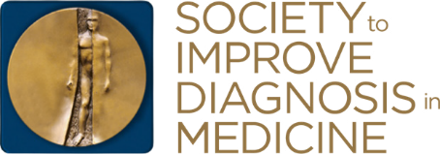
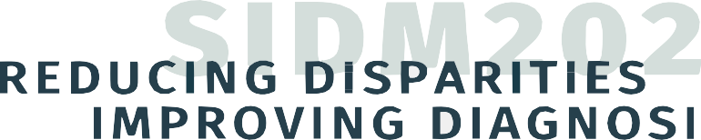

DIAGNOSTIC ERROR IN MEDICINE 14TH ANNUAL INTERNATIONAL CONFERENCE

DISTRIBUTION

TOOLKIT

SIDM2021
October 25-27, 2021 Virtual

This digital toolkit contains messaging that will assist you in spreading the word about SIDM 2021. These turnkey materials can be used with media outlets, stakeholders, and others to share.

SIDM2021

Provided below is information about SIDM2021, and quotes from conference chairs.
EMAIL/NEWSLETTER TEMPLATE:

SHORT EMAIL/NEWSLETTER ARTICLE:
The Society to Improve Diagnosis in Medicine (SIDM) will present its 14th International Diagnostic Error in Medicine Conference (SIDM2021) virtually this October 25-27. This year’s theme is: Reducing Disparities; Improving Diagnosis. Attendees will come together virtually to showcase developments in the field of diagnostic quality and safety while exploring how disparities and inequities contribute to misdiagnosis and diagnostic delays. This includes sharing research, innovations, ideas, and solutions being evaluated or implemented.

Conference content is being directed by the chairs, Drs. Peter Pronovost and Ronald Wyatt, supported by a planning committee representing numerous stakeholder groups. Dr. Wyatt articulated a vision for the conference as a convening where attendees come together as a community to better understand all types of disparities, from race, to gender, to age.

“We need to have difficult, but important conversations about implicit bias and look at how disparities and inequalities contribute to misdiagnosis and diagnostic delays,” said Dr. Wyatt. “We will all have to be comfortable with being uncomfortable during these discussions.”

The conference brings together participants representing the cross-cutting nature of medicine including physicians, patients, nurses, educators, researchers, quality leaders, safety experts, policymakers, and more.

“The pandemic has brought into sharp focus the impact of disparities on health care quality,” added Dr. Pronovost. “Overlooked, however, has been how disparities have long affected the ability to get an accurate, timely, and well-communicated diagnosis.”

The conference will include keynote and plenary presentations, a Patient Summit, interactive breakout sessions, field-submitted workshops, posters presentations, oral abstracts, and multiple networking opportunities. We hope to see you virtually at SIDM2021! Learn more and register today.

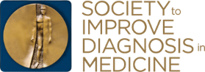

#SIDM2021 Improvediagnosis. org 2

SIDM2021
SOCIAL MEDIA OUTREACH MATERIALS:

Social media, such as Facebook and Twitter, can be powerful tool in spreading messages. Copy and paste any of the sample social media messages we constructed or craft your own message about #SIDM2021. Posts can be accompanied by conference graphics (attached separately).

SAMPLE FACEBOOK:
#SIDM2021, taking place virtually October 25-27, is just around the corner. Throughout this three-day event, attendees will have the opportunity to learn, connect and explore the field of diagnostic quality and safety. Take the first step in advancing your personal and professional development by signing up today: https://bit.ly/sidm2021
SAMPLE TWITTER:
#SIDM2021, taking place virtually Oct. 25-27, will showcase developments in the field of diagnostic quality and safety while exploring how disparities and inequities contribute to misdiagnosis and diagnostic delays. Learn more: https://bit.ly/sidm2021

SAMPLE LINKEDIN:
#SIDM2021 is the Society to Improve Diagnosis in Medicine’s virtual annual conference — and this year’s theme is focused on Reducing Disparities; Improving Diagnosis. Throughout this three-day event, attendees will have the opportunity to learn, connect and explore the field of diagnostic quality and safety. Take the first step in advancing your personal and professional development by registering today: https://bit.ly/sidm2021

#SIDM2021 Improvediagnosis. org 3

SIDM2021
SIDM CONTENT TO SHARE:

Here are some short links about #SIDM2021 that can make sharing a bit easier. Click below to find a SIDM post to retweet or share.
FACEBOOK POSTS TO SHARE:
To access a link, push CTRL and click.
TWEETS TO RETWEET:
To access a link, push CTRL and click.
- Conference Chair Ron Wyatt, MD, MHA Sets Expectations for #SIDM2021
- Quote from Conference Chair Peter Pronovost, MD, PhD
- Register Today – GIF
- Register Today – Graphic
- Conference Chair Ron Wyatt, MD, MHA Sets Expectations for #SIDM2021
- Quote from Conference Chair Peter Pronovost, MD, PhD
- Register Today – GIF
- Register Today – Graphic

LINKEDIN POSTS TO SHARE:
To access a link, push CTRL and click.
- Conference Chair Ron Wyatt, MD, MHA Sets Expectations for #SIDM2021
- Quote from Conference Chair Peter Pronovost, MD, PhD
- Register Today – GIF
- Register Today – Graphic

#SIDM2021 Improvediagnosis. org 4

